**Sollin’s Algorithm**

Sollin’s algorithm is also called Boruvka’s algorithm. It is used to find MST. It was given by Boruvkas in 1926. At that time it was the first algorithm to find the MST.

Boruvka’s Algorithm is a greedy algorithm and is similar to **Kruskal’s algorithm** and Prim’s algorithm.

**Steps of Sollin’s Algorithm**

1) Input is a connected, weighted and un-directed graph.

2) Initialize all vertices as individual components (or sets).

3) Initialize MST as empty.

4) While there are more than one components, do following

for each component.

a) Find the closest weight edge that connects this

component to any other component.

b) Add this closest edge to MST if not already added.

5) Return MST.

Let us understand the algorithm with below example.

[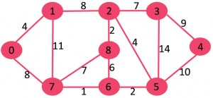](https://media.geeksforgeeks.org/wp-content/cdn-uploads/Fig-0.jpg)  
Initially MST is empty. Every vertex is singe component as highlighted in blue color in below diagram.  
[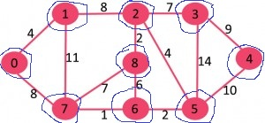](https://media.geeksforgeeks.org/wp-content/cdn-uploads/4.jpg)

For every component, find the cheapest edge that connects it to some other component.

**Component Cheapest Edge that connects**

**it to some other component**

{0} 0-1

{1} 0-1

{2} 2-8

{3} 2-3

{4} 3-4

{5} 5-6

{6} 6-7

{7} 6-7

{8} 2-8

The cheapest edges are highlighted with green color. Now MST becomes {0-1, 2-8, 2-3, 3-4, 5-6, 6-7}.  
[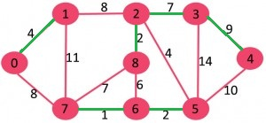](https://media.geeksforgeeks.org/wp-content/cdn-uploads/13.jpg)  
After above step, components are {{0,1}, {2,3,4,8}, {5,6,7}}. The components are encircled with blue color.  
[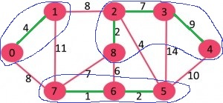](https://media.geeksforgeeks.org/wp-content/cdn-uploads/131.jpg)

We again repeat the step, i.e., for every component, find the cheapest edge that connects it to some other component.

**Component Cheapest Edge that connects**

**it to some other component**

{0,1} 1-2 (or 0-7)

{2,3,4,8} 2-5

{5,6,7} 2-5

The cheapest edges are highlighted with green color. Now MST becomes {0-1, 2-8, 2-3, 3-4, 5-6, 6-7, 1-2, 2-5}  
[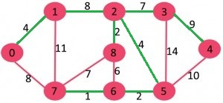](https://media.geeksforgeeks.org/wp-content/cdn-uploads/14.jpg)

At this stage, there is only one component {0, 1, 2, 3, 4, 5, 6, 7, 8} which has all edges. Since there is only one component left, we stop and return MST.

**RELEVANT READING MATERIAL AND REFERENCES:**

**Source Notes:**

1. https://www.geeksforgeeks.org/boruvkas-algorithm-greedy-algo-9/

**Lecture Video:**

1. <https://youtu.be/MFsyfvtQskw>

**Online Notes:**

1. <http://vssut.ac.in/lecture_notes/lecture1428551222.pdf>

**Text Book Reading:**

1. Cormen, Leiserson, Rivest, Stein, “*Introduction to Algorithms*”, Prentice Hall of India, 3rd edition 2012. problem, Graph coloring.

**In addition: PPT can be also be given.**